Hi Sunny –

Thanks so much for taking the time to create the time-lapse animated chart. I understand it was likely difficult to do and I want to thank you for the effort to stand it up.

There are two modifications that I am hoping we can make. Please see the description below.

1 – Can the download numbers for each country be the cumulative value on the day (instead of the daily value as its set currently)? Please see screenshot below:

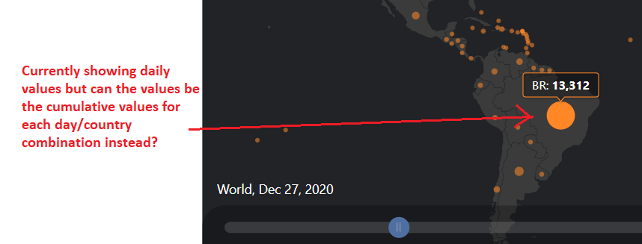

2 – Can the “per capita” function be included as a functionality in our chart as it is in the example on amcharts.com ?

